**Terraform using Modules, CloudWatch, and Ansible**

**Terraform**

In this project, I have written Terraform code for creation of 4 EC2 machines, CloudWatch monitoring. Also installed Ansible by making of one master and 3 nodes. The terraform code will be available in github (<https://github.com/sudheerkumar19/Terraform-Project-with-CloudWatch-Ansible.git>).

1. **Open aws.amazon.com**

1. **Login with credentials.**

1. **Select security credentials by clicking on account.**

1. **Click on “Create New Access Key”**

1. **Download the file to get access key and secret key.**

1. **Now, go to CLI and type aws configure and enter key values to access aws.**

1. **I have uploaded terraform code to the github.**
2. **The first command to give is terraform init.**

1. **Next command to use is “terraform plan”**

1. **We need to allocate resources from the aws. So, we need to execute “terraform apply”.**

1. **Type “yes” and Enter**

1. **Resources are added.**

1. **We check in the aws console, 4 EC2 machines are created.**

**Ansible (Configuration Tool)**

**Now, we are going to connect to the instances. One instance made as server in which we are installing Ansible. The others considered as nodes for configuration of softwares.**

1. **Connect to node1.**

1. **Establish password less ssh connection. change PasswordAuthentication🡪 yes, Save and QUIT**
2. **Repeat the same steps in node2 and node3**

1. **Now, Connect to controller (server).**

1. **We need to generate ssh connections.**

1. **Now copy the key to managed nodes.**

1. **Installing ansible now in controller (server)**

1. **To check whether Ansible installed or not.**

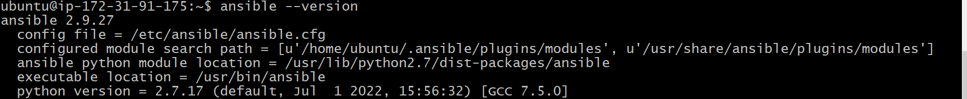

1. **Write the ip address of nodes in the inventory file. cd /etc/ansible, ls, sudo vim hosts**

1. **Creating a role “my-role”.**

1. **Writing code in main.yml in prerequisites, apache, and mongodb to install git, apache, and mongodb into node1, node2, node3.**

**Prerequisites-🡪Tasks-🡪 main.yml**

**Apache -🡪 tasks -🡪 main.yml**

**Mongodab -🡪 tasks -🡪 main.yml**

**Etc/ansible -🡪 stack.yml**

1. **Now, executing stack.yml playbook which has prerequisites, mongodb, and apache roles.**

1. **To check whether apche2 is installed in the node.**

1. **To check whether mongodb installed in the node.**

**CloudWatch (Monitoring Tool)**

I connected those 4 ec2 instances to CloudWatch (code is in the terraform file) to monitor CPU Utilization, Volume check.

1. **Go to aws console, select CloudWatch service.**

1. **CloudWatch Dashboard (Name: View EC2 Dashboard)**

**Here created custom Dashboard: my-instance-db**

**Click on Add widget**

**Select any chart to represent.**

